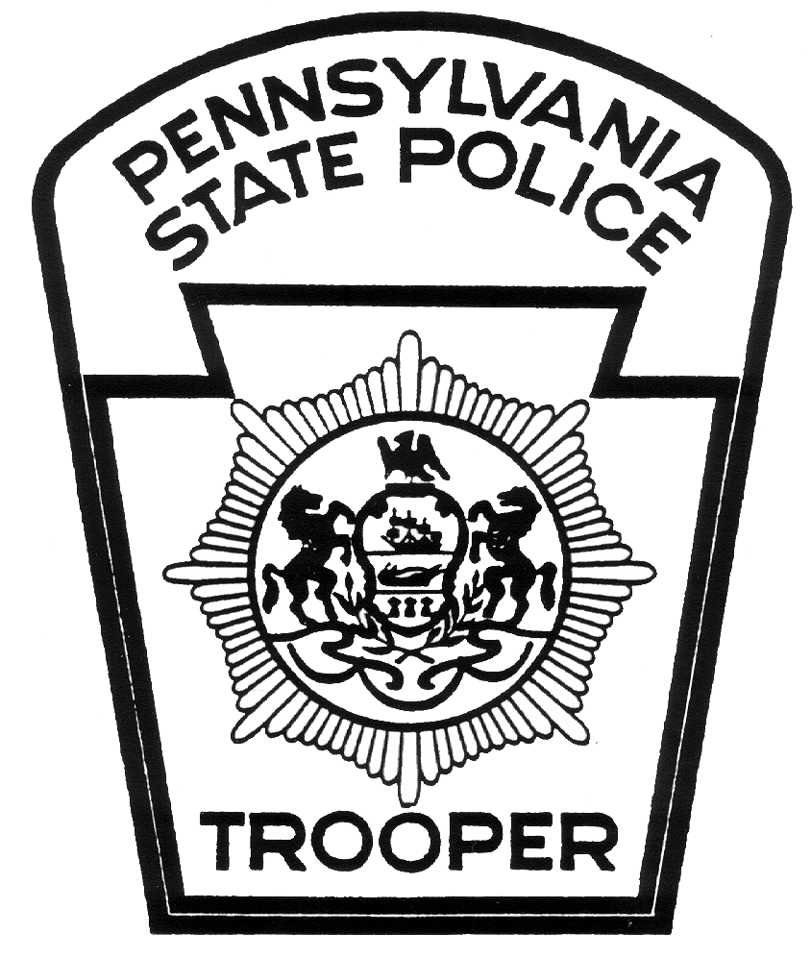 | PENNSYLVANIA STATE POLICE  Bureau of Training and Education  175 East Hersheypark Drive  Hershey, Pennsylvania 17033  Tel: 717-533-9111  Fax: 717-533-1201 | 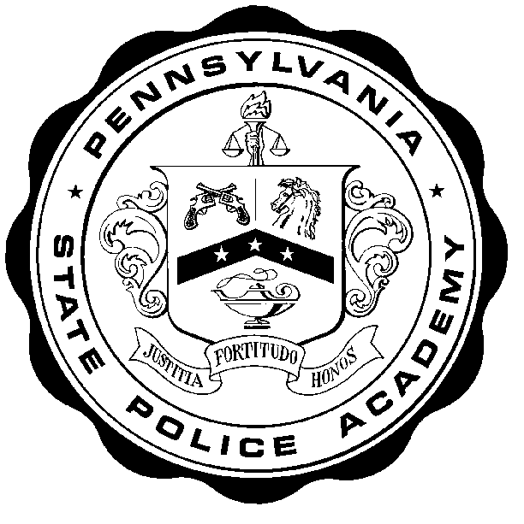
ACADEMY RULES AND REGULATIONS

Welcome to the Pennsylvania State Police Academy. In order to provide you with a positive training experience, we need your cooperation and assistance during your time at our facility. Because this is a professional police training facility, you are expected to comply with the rules and regulations outlined in this document.

1. All personnel who are not in uniform must display an identification card at all times within the Academy buildings and on the Academy grounds.

2. Visitor parking is available in the front (south) parking lot at the crest of the hill along the front entrance road. If the front parking lot is full, an alternate parking area is located in the Cadet/overflow parking lot to the rear (north) of the main building. Please do not park in the Academy staff parking lot, which is to the immediate rear of the main building, or in areas reserved for official Academy vehicles.

3. Please do not interact with Cadets. They are on a strict time schedule and have been instructed not to converse with other trainees.

4. Appropriate attire is required in the classroom and dining hall. Jeans and shorts are not acceptable. Collared shirts are required in the dining hall.

NOTE: Exceptions to wearing appropriate attire in the dining hall must be specifically authorized by the Director, Bureau of Training and Education, or his designee.

5. Cadets shall be allowed through the dining hall service lines first, followed by Academy staff.

The dining hall schedule is as follows:

Breakfast 0630 to 0745 Service line closes at 0730 hours
Lunch 1145 to 1245 Service line closes at 1215 hours
Supper 1645 to 1745 Service line closes at 1715 hours

Individuals who are attending Department-required training, with the exception of Mandatory In-service Training (MIST) and calendar courses, are not required to sign-in and/or pay for their meals. All others will initial their class roster at the lectern in the dining hall.

The dining hall closes at 1800 hours. Use of the dining hall is permitted only during meal times and designated coffee breaks unless prior approval has been received from the Director, Bureau of Training and Education, or his designee. Any snacks provided in the evening are for Cadets only since they do not have the opportunity to leave the premises.

Beverages are permitted in the classroom with the permission of the instructor. Students shall exercise caution around electronic devices and will assume responsibility for any damage caused by a spill. Food is permitted only in the dining hall and the designated snack area on the lower level where snack and beverage machines are located.

6. Smoking and the use of smokeless tobacco shall be confined to the designated outside smoking areas. Proper receptacles shall be used for the disposal of all tobacco waste material. Smoking in front of the building is strictly prohibited. Please do not spit tobacco into water fountains or urinals.

7. Alcoholic beverages are prohibited on State Police property.

8. Department-authorized firearms may be carried on Academy grounds and remain on your person during training courses inside the Academy building; however, the weapon shall not be removed from the holster unless it is intended to be used in the performance of duty. There may be training courses involving firearms, police skills, or scenario training which prohibit the carrying of a loaded firearm into the classroom for instruction. Trainees shall follow the instructor’s directions in those courses and properly secure the firearm(s) in their vehicle. Trainees and personnel shall not leave a firearm unsecured or unattended in the Academy building or on the Academy grounds under any circumstances.

9. Each resident trainee is required to bring their own towels and wash cloths and to maintain his/her section of a dormitory room in proper order. Beds shall be made each morning with provided or personal linen. If needed, a trash bag will be provided for use as a laundry bag. On the day of departure, please place used linens in the pillow case and place the pillow case in the hallway. All rooms must be vacated prior to lunch meal.

10. The Academy Fire/Emergency Plan provides for the safe and systematic evacuation of the building. In the event of an emergency or when the Academy is conducting a fire drill, the fire alarm will sound. All occupants of the building are required to immediately exit the building by using the exit door nearest their location. Do not attempt to go to any other part of the building. Upon exiting the building, proceed to the parade field (west side of the building) and wait for instructions to return to the building.

11. You must check-in and check-out at the information desk in the front of the building each time you leave the premises. The check-in and check-out procedure will assist Academy staff with emergency messages or in the case of a fire emergency.

12. Individuals leaving or returning after 1800 hours are required to use the main entrance of the building. When returning after hours, please respect other trainees and keep noise to a minimum. Anyone planning to lodge overnight shall return to the Academy no later than 0100 hours.

13. The gymnasium is available for use as posted on the gymnasium door. Appropriate rubber-soled gym footwear is required. Exercise equipment is not to be removed from the gymnasium or abused in any manner. If you are the last to leave the gymnasium, please turn off all lights and close all doors. An informed consent form, available at the front desk, must be signed prior to using the gymnasium or weight room.

14. The Medical Unit is available between 0800 hours and 1630 hours on normal work days. If illness or injury occurs during a time other than these hours, contact the Charge of Quarters for assistance.

15. A television set is available in the student lounge located on the first floor, adjacent to the Lecture Hall. If you are the last to leave the area, please turn the television and lights off.

16. A telephone is located in the lobby for business use. Please do not use telephones in Academy offices, the library, or the officers’ dining hall without first obtaining authorization. Check with the information desk personnel for proper access codes before attempting to use the telephone.

17. The staff locker room and all facilities located therein are restricted to the use of Academy staff only. Male visitors may use the locker room near the gymnasium; female visitors may use the locker room located within the gymnasium weight room.

18. If you receive an emergency call, desk personnel will immediately contact you. If you receive a non-emergency call, desk personnel will take a message. Messages will be posted on the in-service message board located in the main hall outside of the information office. It is your responsibility to check and retrieve messages from the board.

If any emergencies, illnesses, or questions regarding the Academy’s policies arise during normal work hours, contact any member of the Academy staff. During other hours, contact the Charge of Quarters.

Failure to comply with the provisions listed within this document or any special instructions provided by members of the Academy staff will result in the termination of your attendance in the training course and your stay here at the Academy.

Major George E. Bivens
Director
Revised 04/09/2019 Bureau of Training and Education

